# VISVESVARAYA TECHNOLOGICAL UNIVERSITY

## JNANA SANGAMA, BELAGAVI, KARNATAKA-590 018

**Mini Project Report**

**On**

## “Brain tumour detection using image processing”

Submitted in Partial Fulfillment of the requirement of

## Mini Project [18ECMP68]

In

## ELECTRONICS AND COMMUNICATION ENGINEERING

By

## GAURAV KUMAR [4MU18ECXXX]

Under the guidance of



**XXXX  
 Assistant Professor Dept. of E&C, MRIT**

**DEPARTMENT OF ELECTRONICS AND COMMUNICATION ENGINEERING**

**INSTITUTE OF TECHNOLOGY**

X LOCATION

**Academic Year: 2020 – 2021**

# Content No. Page

* **ABSTRACT**
* **INTRODUCTION 1**
* **LITERATURE SURVEY 1-2**
* **METHODOLOGY 2-7**
* **SOFTWARE SPECIFICATION 7**
* **MATLAB CODE 8**
* **RESULTS AND DISCUSSION 9-10**
* **BENEFITS & APPLICATION 11**
* **CONCLUSION AND FUTURE WORK 12**
* **REFERENCES 13**

**LIST OF FIGURES**

**Fig. No. Description Page No.**

1. MRI of Brain tumour 3
2. Tumour in the Brain 3
3. Pre-Processing stage 4
4. Images Enhancement and Filtering of image 5
5. Different stages of feature extraction 6
6. Showing the result of the taken MRI image &

providing the classification of type of tumour 7

1. Detection of Brain tumour with the use of

Matlab-code 10-11

**Abstract**

Brain tumor detection and classification is that the most troublesome and tedious task within the space of medicative image getting ready. Magnetic resonance imaging (Magnetic Resonance Imaging) may be a medicative procedure, typically adopted by the medical specialist for illustration of inner structure of the build with no surgery. Magnetic resonance imaging provides long information concerning the human delicate tissue, that helps within the conclusion of brain tumor. Precise segmentation of magnetic resonance imaging image is basic for the conclusion of brain tumor by laptop supported clinical device. This paper is concentrated towards the look of Associate in Nursing best and additional correct approach for the detection of neoplasm from brain magnetic resonance imaging scans and if it confirms the presence of tumor then it's focused on evaluating its stage, i.e., benign or malignant. We’ve through an experiment shown that our projected methodology features a larger accuracy than different existent strategies for classifying tumor kind to be either as Malignant or Benign.

**Keywords:** Image Segmentation, Support Vector Machine, Self-Organiz

## Introduction:

## This project proposes two different methodologies to segment a tumor from an MRI image and determine the type of tumor. For this one segmentation and one clustering techniques have been implemented. Each MRI image is passed through an imaging chain where the image is preprocessed to remove noise and is further enhanced to improve the contrast of the image. This paper proposes two different techniques which are then applied on the image to extract the tumor. These segmentation techniques include SOM Clustering and SVM Classification. Applying each of the segmentation techniques allows us to determine the most appropriate method to segment the tumor from each of the images. The tumor region represents the pixel values for the foreground points extracted using the ginput() command from a texture image. The texture image is generated by applying the rangefilt() method. In order to enhance the texture characteristics of the image, smoothing filter is applied to the texture image. In this project, the major challenge faced was to locate and extract the proper tumor region from the image. Due to several lighting issues, unnecessary white portions were present in the image which could wrongly be segmented as a tumor. Also the unwanted noise and reduced contrast displays several regions from the image that are falsely claimed as a tumor. Another challenge faced was degraded quality of the MRI image due to several problems that would have occurred during the acquisition stage.

**Literature Survey**

Swapnil R.Telrandhe, et.al [11] Proposed tumor detection inside which Segmentation separates an image into parts of regions or objects. In this it has to segment the item from the background to browse the image properly and classify the content of the image strictly. During this framework, edge detection is a vital tool for image segmentation. In this paper their effort was made to study the performance of most commonly used edge detection techniques for image segmentation and additionally the comparison of these techniques was carried out with an experiment. Malathi Hong-Long et.al [12] , proposed approach by desegregation wave entropy based mostly spider net plots and probabilistic neural network for the classification of Brain MRI. Proposed technique uses two steps for classification one is wavelet entropy based mostly spider net plo t for feature withdrawal and probabilistic neural network for classification. The obtained brain magnetic resonance image, the feature extraction was done by wavelet remodel and its entropy worth was calculated and spider net plot space calculation was done. With the assistance of entropy worth classification of probabilistic neural network was calculated. Probabilistic neural network provides a general resolution for pattern classification. Rajeshwari G tayade et.al [13], in their paper they gave a mixture of wavelet statistical features and co-occurrence wavelet texture feature obtained from two level distinct riffle remodel was used for the organization of abnormal brain matters in to benign and malignant. The planned system was consists of four stages: segmentation of region of interest, separate ripple disintegration, feature abstraction, feature choice, organization and analysis. The support vector machine was used for tumor segmentation. A grouping of WST and WCT was used for feature extraction of neoplasm

region extracted from second level separate ripple remodel. Genetic algorithm was used to choose the best texture options from the set of well-mined options. The probabilistic neural network was used to classify abnormal brain tissue in to benign and malignant and also the performance analysis was done by scrutening the classification results of PNN with alternative neural network classifier Lukas Let.al [14], proposed the work on information among the medical image and thereby vastly improve upon the machine speed for growth segmentation results. Significant feature points primarily based approach for primary brain tumour segmentation was planned. Axial slices of weighted Brain pictures with distinction improvement are analyzed. So as to extract vital feature points within the image, applied a feature purpose extraction rule based on a fusion of edge maps exploitation morphological and wave ways. Analysis of feature points so obtained has been done by geometric transformations and image scaling. A region growing algorithmic program was then utilized to isolate the tumor region. Preliminary results show that our approach has achieved good segmentation results. Also this approach was reduces a large quantity of calculation. Future

work can involve associate investigation of the strategy in automatic 3D neoplasm segmentation, segmentation of ROI’s in alternative medical pictures, still because the importance of enforced technique in medical image retrieval

**PROPOSED METHOD**

In this project, we have described our objective in two parts, the first half deals with detection of brain tumor that is the presence of the tumor in the provided MRI. The other part that is the second part contains the classification of the tumor. Here, we will analyze the MRI images which will conclude the stage of the tumor as benign or malignant. In general the diagram for our process. The input images will undergo various stages which can be summarized as follows that are shown in the figure 1.

1. MRI of Brain Images
2. Pre-Processing
3. Images Enhancement and Filtering
4. Feature Extraction
5. Image Analysis

**MRI of Brain images**

This is the first step of our proposed project .In this the data is been provided that is the magnetic resonance images(MRI) that are been collected in their original format’s that are (.ima, .dcm). Mostly the mri images are of .dcm (DICOM[13]) Digital imaging and communications in medicine. We have used file operations fopen(), fclose() available in matlab to read MRI images. Here the gray scale MRI images are been provided as input to the system.

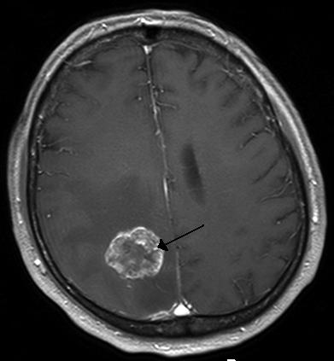

**Fig 1:** MRI of Brain tumour

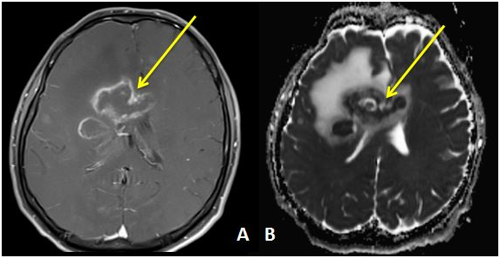

**Fig 2:** Tumour in the Brain

**Pre-Processing**

Pre-processing phase of our project mainly involves those operations that are ordinarily essential before the goal analysis and extraction of the required data and ordinarily geometric corrections of the initial image. These enhancements embrace correcting the information for irregularities and unwanted region noise, removal of non-brain element image and converting the data so that they are correctly reflected in the original image. The first step of preprocessing is the conversion of the given input MRI image into a suitable form on which further work can be performed.

This conversion of DICOM image to .jpeg is done by using function dicom2image()[7]. Major issues related to the preprocessing stage are as follows:-

a. Noise,

b. Blur Low Contrast,

c. The bias,

d. The partial-volume effect.

This pre-processing stage is used for reducing image noise, highlighting important portions, or displaying obvious portions of digital images.

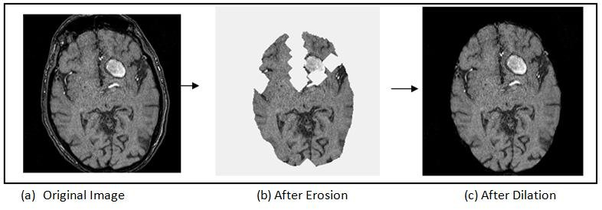

**Fig 3:** Pre-Processing stage

**Images Enhancement and Filtering**

In this project image improvement that is the improvement of digital image quality with none of the data concerning the first supply image degradation. The enhancement of the image starts by first converting the gray scale image to black and white image this is done by the use of function im2bw(gray_image)[7].Here the threshold value taken in our project is 0.6.As Image improvement strategies improve the visual look of pictures from tomography and also the distinction enhancing brain volumes are linearly associated. For image sharpening the imsharpen()[7] is been used,similiarly imadjust()[7] for image adjustment, freqz() for setting frequency response of image are been used.The Gaussian smoothing operator is been for the two dimensional image convolution operators that is used to `blur' images and remove detail and noise.Gaussian is random incidence of white intensity worth and its intensity worth is drawn from Gaussian distribution, thus it is very much use to reduce Gaussian noise and as with linear filter it's computationally economical and enhances image quality with the image boundaries.for implementation of gaussian filter the imgaussfilt()[7] is been used in our project. Color areas,which indicate the colors in an exceedingly benchmark approach by employing a reference frame and a topological space within which every color is delineated by one point of the coordinate system. The colour spaces used in our image processing methods are Gray, Binary form and RGB.

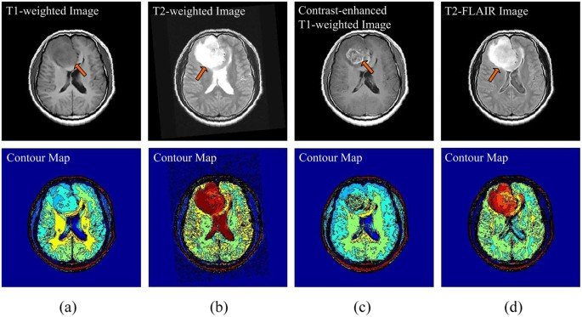

**Fig 4**: Images Enhancement and Filtering of image

**Feature Extraction**

In this phase the features of the given input image is been extracted . These features include smoothness, entropy, variance, kutosis, skewness, idm, correlation, homogeneity, mean and standard deviation . And on the basis of these features the image is analysed and the detection of the tumor region is been done. Below in the figure 2 there are output result of an mri image uptill the feature extraction phase of the project.

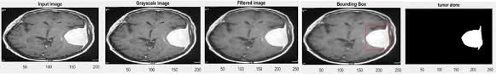

(a)Input image, (b)Grayscale image, (c)Tumor alone image, (d)Tumor outline, (e)Detected tumor.

**Fig 5:** Different stages of feature extraction

**Image Analysis**

After the type of tumor is been identified the image analysis is been done to determine the accuracy of the result. Here in this project four type of accuracy are been shown that are Rbf accuracy, Linear accuracy, Polygonal accuracy and Quadratic accuracy. These accuracies help in analysis of the image result.

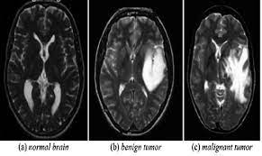

Showing the result of the taken mri image and providing the classification of the type of tumor.

**Fig 6:** Showing the result of the taken MRI image & providing the classification of type of tumour

**SOFTWARE SPECIFICATION**

SOFTWARE : MATLAB

Version : 21a

MATLAB provide by company math works works is a programming environment used for performing mathematical computation , programming and visualization.

It is a powerful tool that includes its own high-level language and functions for performing math-related tasks faster.

**MATLAB CODE**  
  
  
global img1 img2

[path, nofile] = imgetfile();

if nofile

msgbox(sprints('Image NOT Found !!!'), 'ERROR', 'Warning');

return

end

img1 = imread(path);

img1 = im2double(img1);

img2 = img1;

axes(handles.axes1);

imshow(img1)

title('\fontsize{20}\color[rgb]{0.996, 0.592, 0.0} Brain MRI')  
  
  
global img1

axes(handles.axes2);

bw = im2bw(img1, 0.7);

label = bwlable(bw);

stats = regionprops(label, 'Solidity', 'Area');

density = [stats.Solidity];

area = [stats.Area];

high_dense_area = density > 0.5;

max_area = max(area(high_dense_area));

tumor_label = find(area == max_area);

tumor = ismember(label, tumor_label);

se = strel('square' ,5);

tumor = imdilate(tumor , se)

Bound = bwboundaries(tumor, 'noholes');

imshow(img1);

hold on

for i=1: length(Bound)

plot(Bound{i}(:,2), Bound{i} (:,1), 'y' , 'linwidth', 1.75)

end

title('\fontsize{20}\color[rgb]{0.996, 0.592, 0.0} Tumor Detected!');

hold off

axes(handles.axes)  
  
  
  
  
  
  
  
  
  
**RESULT & DISCUSSION**

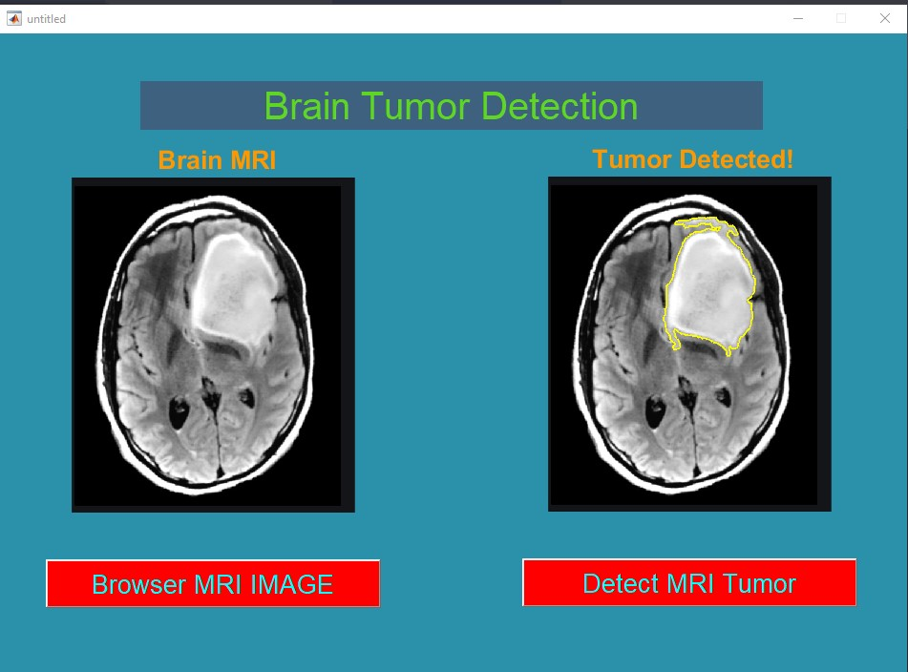

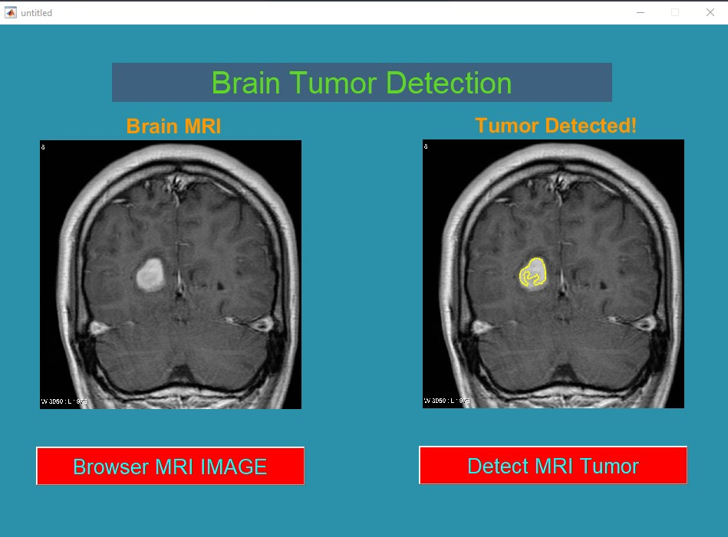

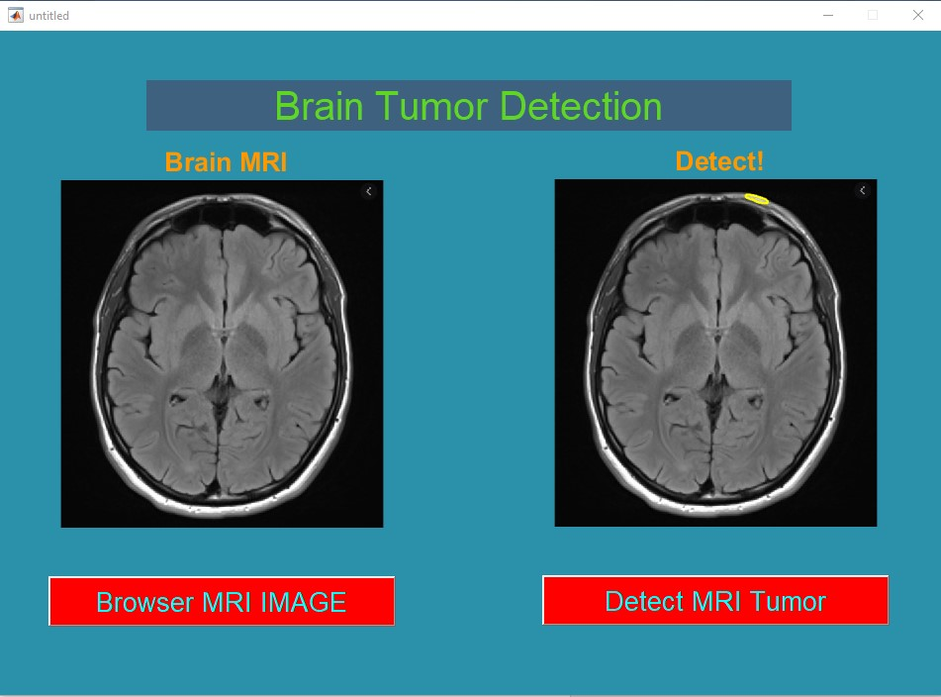

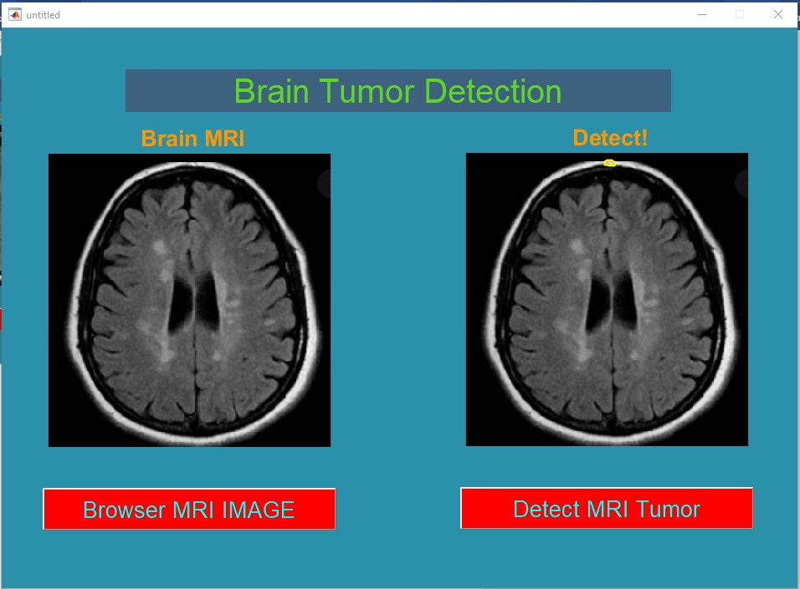

**Fig 7**: Detection of Brain tumour with the use of Matlab-code

**BENEFITS**

The main goal of medical image processing is to identify accurate and meaningful information using images with the minimum error possible.

MRI is mainly used to get images of the human body and cancerous tissues because of its high resolution and better quality images compared with other imaging technologies

**APPLICATIONS**

Biomedical Image processing is a growing and demanding field.

It comprises of many different types of imaging methods likes CT scans,X-Ray and MRI.

These techniques allow us to identify even the smallest abnormalities in the human body

MATLAB has image and data processing capabilities, so can be used for **analysis of medical imaging data**, such as in nuclear medicine, CT, MRI and fluorescein angiogram images. UoB researchers have also used image analysis on microscope and other types of images to detect disease such as brain tumour cancer & etc…

**CONCLUSION**

In this project we have automated the diagnosis procedure for the brain tumor detection by the use of image processing. Apart from several existing brain tumor segmentation and detection methodology are present for MRI of brain image our project has proved to provide an aver all accuracy by upto 97%. All the steps for detecting brain tumor that have been discussed startimg from mri image acquisition ,pre-processing steps to successfully classification of the tumor using the two segmentation techniques is been done. Pre-processing involves operations like wavelet based methods has been discussed. Quality enhancement and filtering are important because edge sharpening, enhancement, noise removal and undesirable background removal are improved the image quality as well as the detection procedure. Among the different filtering technique, Gaussian filter suppressed the noise without blurring the edges and it is better outlier without reducing sharpness of the images. reduces the noise; enhance the image quality and computationally more efficient than other filtering methodology. After the image quality improvement and noise reduction discussed here, segmentation methodology for a brain tumor from MRI of brain image is been used. Classification based segmentation segment tumor accurately and manufacture sensible results for big information set however undesirable behaviours can occur in case wherever a category is unrepresented in training data. Clustered based segmentation performs is straight forward, quick and manufacture sensible results for non-noise image except for noise pictures it leads to serious inaccuracy within the segmentation . In neural network based segmentation perform better on noise field and no need of assumption of any fundamental data allocation but learning process is one of the great disadvantages of it. In spite of several dealing of problems, an automization of brain tumor segmentation using combination of threshold based and classification with SVM and SOM overcame the problems and gives effective and accurate results for brain tumor detection. These classification methods are able to firstly detect weather there is tumor or not and if it is there then they are able to determine weather the tumor is benign or malignant type.

**REFERENCES**

* MathWorks(<https://in.mathworks.com/help/wavelet/ug/lifting-method-for-constructing-wavelets.html>).
* Amrutha Ravi, “Medical Image Segmentation”, Computer Methods And Programs In Biomedicine 84 (2006) 63–65.
* Brain Tumor Detection using Wavelet Based Image Fusion

Youtube : <https://www.youtube.com/watch?v=tCUkyoDR5t0>

* Sijbers J et al (1998), “Estimation of the noise in magnitude MR images”, Magn Reson Imaging 16(1):87–90.
* An S, An D (1984) Stochastic relaxation, Gibbs distributions, and the Bayesian restoration of images. IEEE Trans Pattern Anal Mach Intell 6:721–741
* Nowak RD (1999) Wavelet-based Rician noise removal for magnetic resonance imaging. IEEE Trans Image Process 8(10):1408–1419.
* Swapnil R.Telrandhe,”segmentation methods for medical image analysis”,tesis no 1434,center for medical image science and visualization ,se-58185 linkoping ,Sweden.
* Malathi Hong-Long , , “Segmentation C- Means Clustering With Spatial Information For Image Segmentation,” Computerized Medical Imaging And Graphics 30 (2006) 9–15.
* Rajeshwari G tayade,Michel Crucian , “Unsupervised And Semi-Supervised Clustering: A Brief Survey,” Inria Rocquencourt, B.P. 105 78153 Le Chesnay Cedex, France.

* Lukas L. et Al. Brain Tumor Classification Based On Long Echo Proton Mrs Signals.